NAME: VENKATRAMAMOORTHY.G
- Write a function to add two numbers.
This is a normal function. It takes two inputs (a, b) and returns their sum.
CODE:
function add(a,b){
console.log(a+b);
}
add(1,2);
OUTPUT:
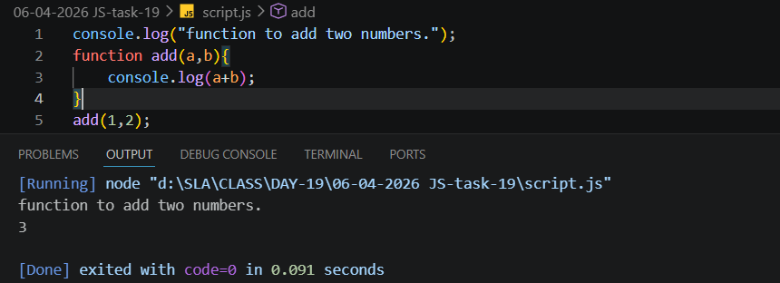
- Write a function expression to multiply two numbers.
A function is stored inside a variable (multiply). It works the same as a normal function.
CODE:
let mul=function(a,b){console.log(a*b)};
mul(2,3);
OUTPUT:
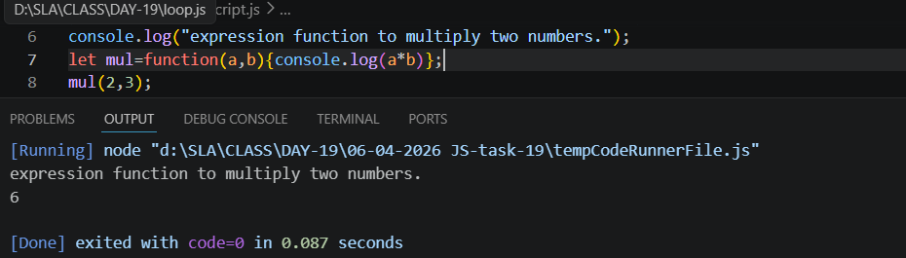

- Write an arrow function to subtract two numbers.
Shorter syntax. It automatically returns the result of a - b.
CODE:
let sub=(a,b)=>console.log(a-b);
sub(10,5);
OUTPUT:
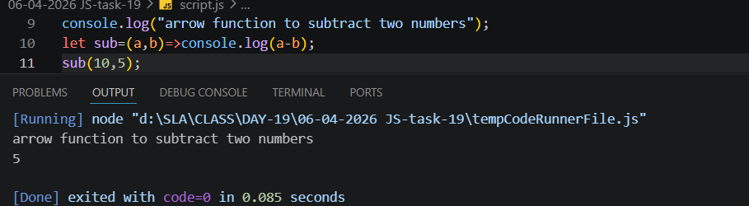
- Write a function with parameters and return a value.
Takes a parameter (name) and returns a message using that value.
CODE:
function divied(a,b){
return(a/b);
}
console.log(divied(10,5));
OUTPUT:
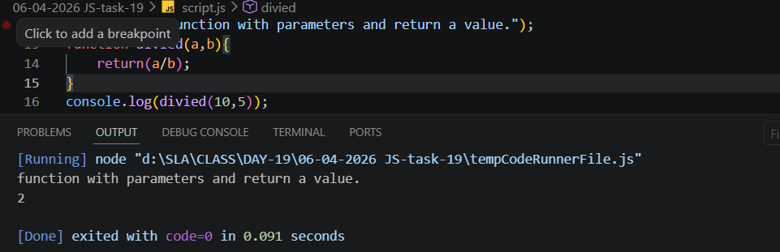
- Demonstrate global vs local scope.
Global variable it can be used anywhere in the code.
Local variable it is only works inside the function where it is created.
CODE:
let a=10;//Global variable or Scope
if(true){
console.log("its a global scope",a);
let b=5;
console.log("its a local scope",b)
}
OUTPUT:
